Project Design Phase-II
Technology Stack (Architecture & Stack)

Date | 28 June 2026
Team ID | Not Given
Project Name | Rising Waters
Maximum Marks | 4 Marks

Team Members | Skill Wallet Team ID’s | Roll Numbers (College: ACET)
Mohana Deepika Kancherla (Team Leader) | SWUID2026226898 | 23MH1A0596
Flora Disowja Sarugolu | SWUID2026212008 | 24P35A0549
Santhi Illa | SWUID2026212021 | 24P35A0550
Mathan Bhavesh Hari Raghava Krishna Munaga | SWUID2026212007 | 24P35A0532

Technical Architecture:
The Deliverable shall include the architectural diagram as below and the information as per the table1 & table 2
Reference: https://developer.ibm.com/patterns/ai-powered-backend-system-for-order-processing-during-pandemics/

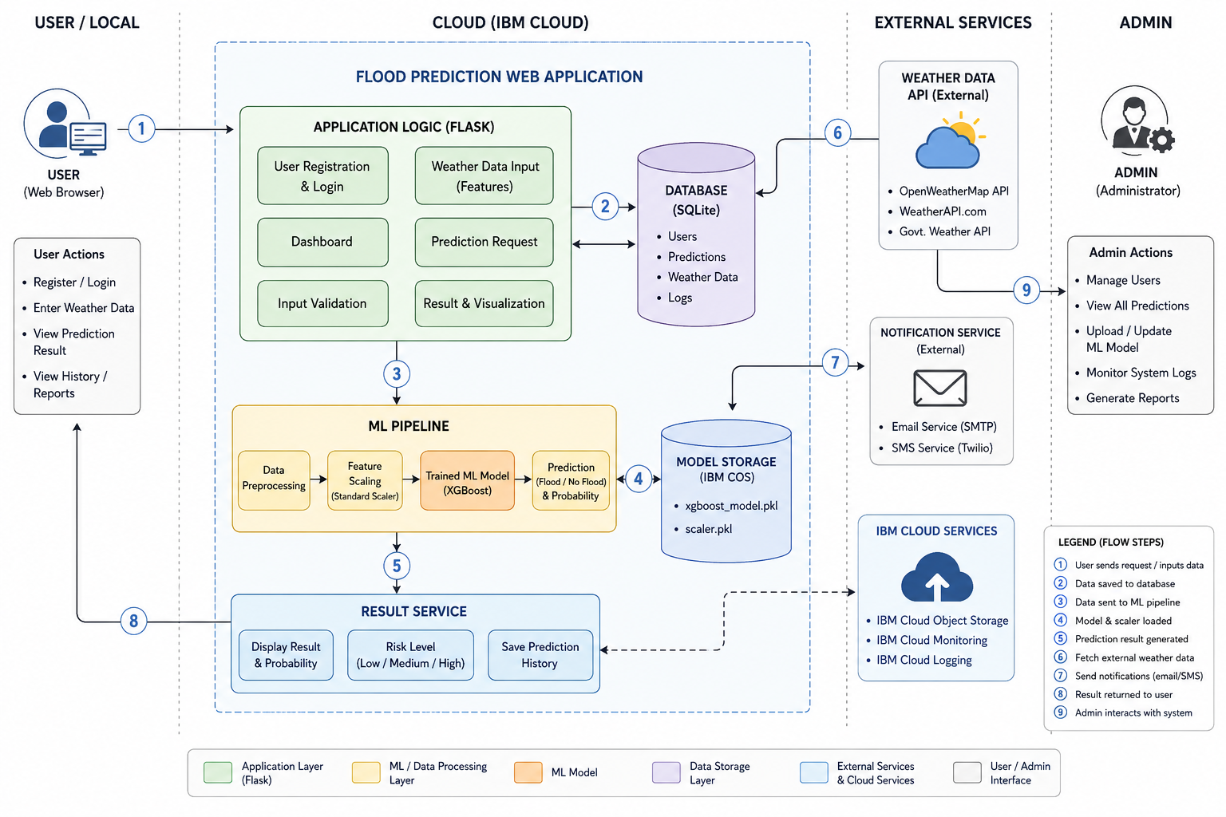
Guidelines:
Include all the processes (As an application logic / Technology Block)
Provide infrastructural demarcation (Local / Cloud)
Indicate external interfaces (third party API’s etc.)
Indicate Data Storage components / services
Indicate interface to machine learning models (if applicable)

Table-1 : Components & Technologies:
S.No | Component | Description | Technology
 | User Interface | Web interface for users to register, log in, enter weather parameters, and view flood prediction results. | HTML, CSS, JavaScript, Bootstrap
 | Application Logic-1 | Handles user authentication, routing, dashboard, and request processing. | Flask (Python)
 | Application Logic-2 | Validates user input, preprocesses weather data, and performs feature scaling before prediction. | Python, Scikit-learn (StandardScaler), Joblib
 | Application Logic-3 | Loads the trained machine learning model and generates flood predictions. | XGBoost, Scikit-learn
 | Database | Stores user information, weather inputs, prediction history, and system logs. | SQLite
 | Cloud Database | Stores prediction records and application data after cloud deployment (optional). | IBM Cloud Databases / IBM Db2
 | File Storage | Stores trained ML model, scaler object, datasets, and generated reports. | IBM Cloud Object Storage / Local File System
 | External API-1 | Retrieves live weather information for prediction (optional enhancement). | OpenWeatherMap API / WeatherAPI
 | External API-2 | Sends alerts or notifications to users (optional enhancement). | Twilio API / SMTP Email API
 | Machine Learning Model | Predicts flood occurrence using historical weather data and selected features. | XGBoost, Decision Tree, Random Forest, KNN
 | Infrastructure (Server / Cloud) | Hosts the Flask application and ML model for public access. : | IBM Cloud, Docker (optional), Local Server

Table-2: Application Characteristics:
S.No | Characteristics | Description | Technology
 | Open-Source Frameworks | Frameworks and libraries used to develop the web application and machine learning model. | Flask, Python, Scikit-learn, XGBoost, Pandas, NumPy
 | Security Implementations | Secure user authentication, input validation, password protection, and secure communication. | Flask Authentication, Werkzeug Password Hashing, HTTPS
 | Scalable Architecture | Modular architecture separating UI, application logic, machine learning, and database for easy scalability. | Flask, IBM Cloud, REST API
 | Availability | The application is deployed on the cloud and can be accessed by authorized users anytime. | IBM Cloud, IBM Cloud Object Storage
 | Performance | Optimized preprocessing and prediction pipeline to provide fast and accurate flood predictions with minimal response time. | XGBoost, Joblib, Scikit-learn, SQLite

References:
https://c4model.com/
https://developer.ibm.com/patterns/online-order-processing-system-during-pandemic/
https://www.ibm.com/cloud/architecture
https://aws.amazon.com/architecture
https://medium.com/the-internal-startup/how-to-draw-useful-technical-architecture-diagrams-2d20c9fda90d

